**X-Ray Reflectivity analysis for experimental setup**

**Using Reflex**



https://reflex.irdl.fr/Reflex/

Contents

1. General notes 3

2. Interface overview 4

2.1 Region 1(sample structure) 4

2.2 Region 2(Parameters for measurement) 4

2.3 Region3(Parameters used to calculate XRR curves) 6

3. Menubars 8

3.1 Calculation 8

3.2 Edit data 8

3.3 Parameters 10

3.4 Experimental Setup 10

4. Experiment 11

5. Limitations 13

# General notes

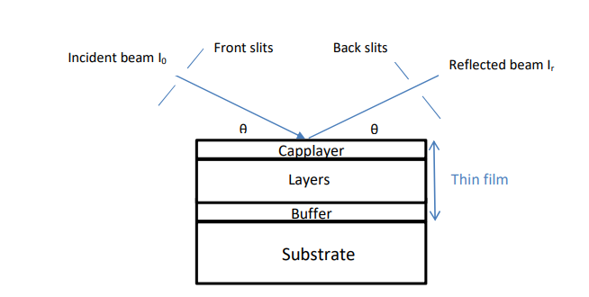In a typical specular x-ray reflectivity experiment, a collimated beam is impinging on the surface of a flat sample at an incident angle θ. The reflectivity (R) is measured as a function of the wave vector transfer qz which for specular reflectivity is perpendicular to the surface and is given by qz = 4π sinθ/λ. The specular reflectivity is defined as the ratio of the reflected to the incident intensity R = IR/I0 is measured as a function of increasing wave vector transfer.

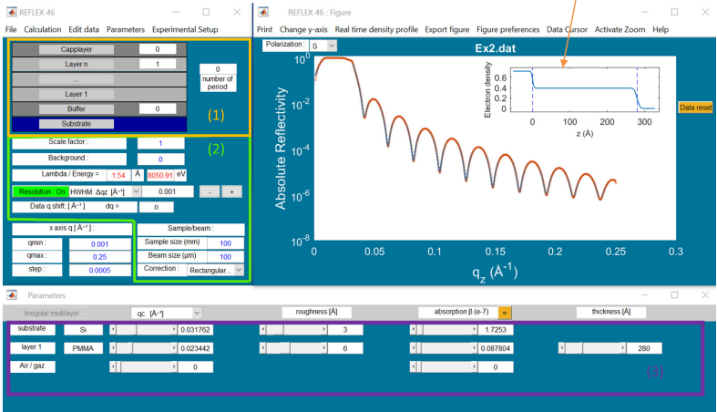REFLEX can be working as an executable file under windows. When running the program, three windows will be displayed on the screen as shown below

The top right window shows the measured and calculated refelctivity, the top left window provides essential information about the sample itself together with information about the energy of incident radiation and instrumental parameters. Finally the bottom window depends on the parameters put in the top left window and is basically providing information about the slabs constituting the stacking on the substrate. Note that the sequence always starts with the substrate and ends up with air or a fluid in contact with the sample. We first start with the explanation of the content of each window starting with the one in the top left window.

# Interface overview

## Region 1(sample structure):

* The number of “Cap layers” is the number of layers in contact with the air
* “Layer n” is the number of layers that are repeated inside the multilayer
* "Number of period" refers to the number of repeated periods of this cell
* inside the multilayer
* The number of “Buffer” is the number of layers at the substrate/film interface.

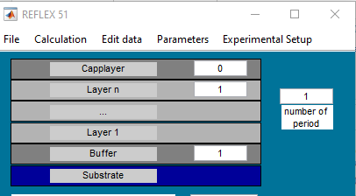

## Region 2(Parameters for measurement):

* The scale factor allows adjusting the normalization of the data. To extract the normalized reflectivity from the data, usually the reflected intensity is divided by the intensity of the direct beam(obtained by scanning the detector into the direct beam after having carefully attenuated the direct beam to avoid detector saturation)
* The background adds a constant value at all qz values. The background can be estimated from an off specular reflectivity measurement.
* Lambda/Energy is the wavelength (or the energy) of the incident beam in angstrom (or in electron volt)
* Data q shift allows correcting a possible misalignment of the zero of the detector. In such a case the scattering angle set to θ is a little bit shifted and becomes θ+∆θ. Usually, you should not have to use this parameter.
* Instrumental resolution is handled by convolving the calculated reflectivity curve with a Gaussian. The Half Width at Half Maximum (HWHM) of which is related to the instrument resolution by

where w is the HWHM of the direct through beam. The lower is this value the better the resolution giving rise to a better estimation of some critical features like the Kiessig fringes minima or the critical angle

* 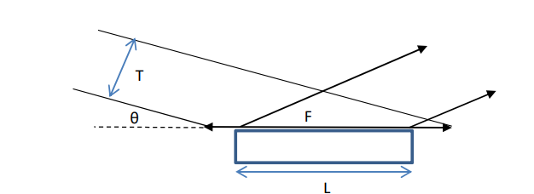Sample/beam: These parameters provide information about the geometry of the sample and of the incident beam. As XRR measurements usually start below the critical angle of external reflection, the footprint of the beam (F) on the sample is frequently larger than the length (L) of the sample along the direction of the incident beam. As a consequence, even below the critical angle for external reflection, only a part of the incident intensity is totally reflected by the sample. The reflectivity is thus less than 1.

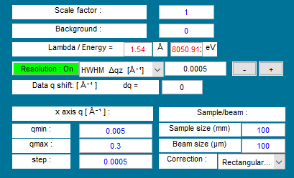

## Region3(Parameters used to calculate XRR curves):

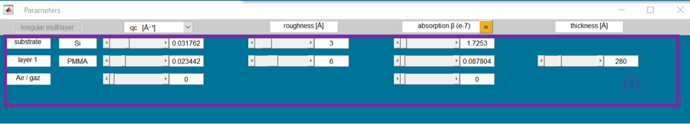

* The Reflex optical-constants database contains data for over 110 materials. The optical-constants database is a directory of ASCII files, in which each optical-constants file contains three columns of optical data (Energy, f', and f") associated with a single material. In order to create an additional optical constant, a user need only fill in a menu (Parameters ⇒ Database ⇒ Add new material) with its chemical formula and equally important its density.

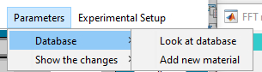

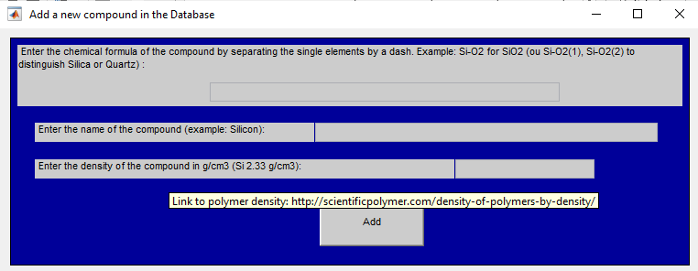

* The program automatically extracts the anomalous atomic form factor (real f’ and imaginary f’’ part) from the database and creates a new ASCII file containing the optical constants for the desired material in accord with the existing format.

# Menu bars

## Calculation

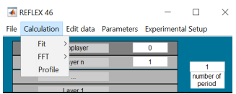

* **Fit reflectivity**: opens a calculation window to fit the data
* **Fit reflectivity+autoccorelation function (Patterson functions)** : as above but in addition to the reflectivity curve, the autocorrelation function is fitted. The simultaneous refinement of the reflectivity in real-space and reciprocal space does not only improve the sensitivity to certain parameters but may also prevent the usually applied local optimization techniques from getting stuck in local minima. It can be applied to any reflectivity data from low-contrast layer systems.
* **FFT**: gives the Fourier transform of the reflectivity curve normalized by the Fresnel reflectivity of the substrate. This data inversion gives the autocorrelation function of the first derivative of the electron density.
* **Profile**: calculates the Electron density profile from the fit to the data. Note that the text (Film, Substrate,…) can be directly moved with the mouse.

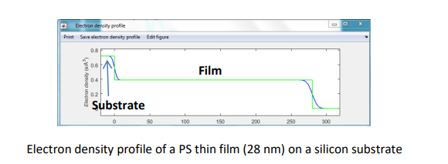

## Edit data

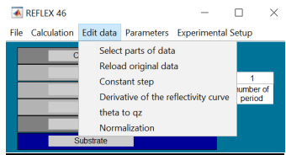

* **Select parts of data**: The user can select manually and easily a part of the reflectivity curve.
* **Reload original data**: Reload the original data (not modified).
* C**onstant step**:
* this shortcut menu is useful to calculate the data with a constant step.
* To make the data adjustment, calculated curve takes the same step that the data.
* If the step is not constant, this presents a problem for the convolution of the calculated reflectivity curve with the resolution function.
* Derivative of the reflex curve: this menu allows to derive the reflectivity curve to locate the position of the qc.

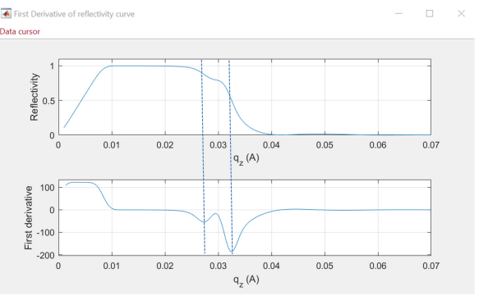

## Parameters

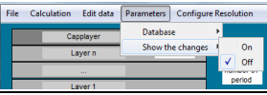

Database: allows to consult the compounds present in the database and to add new compounds. Show the changes: when is On, it makes possible to follow the evolution of the calculated reflectivity curve when some parameters are modified.

Show the changes: when is On, it makes possible to follow the evolution of the calculated reflectivity curve when some parameters are modified

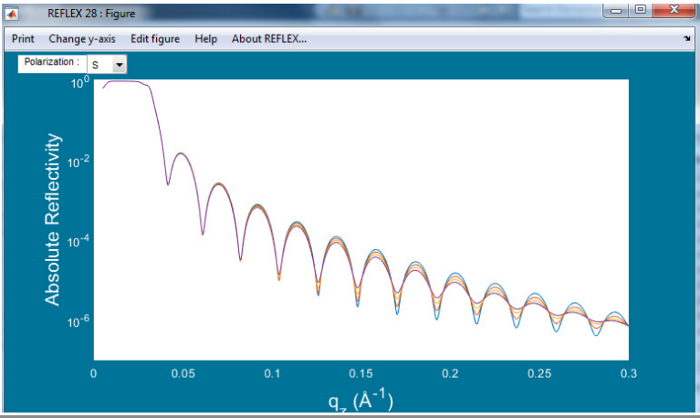

# Experiment

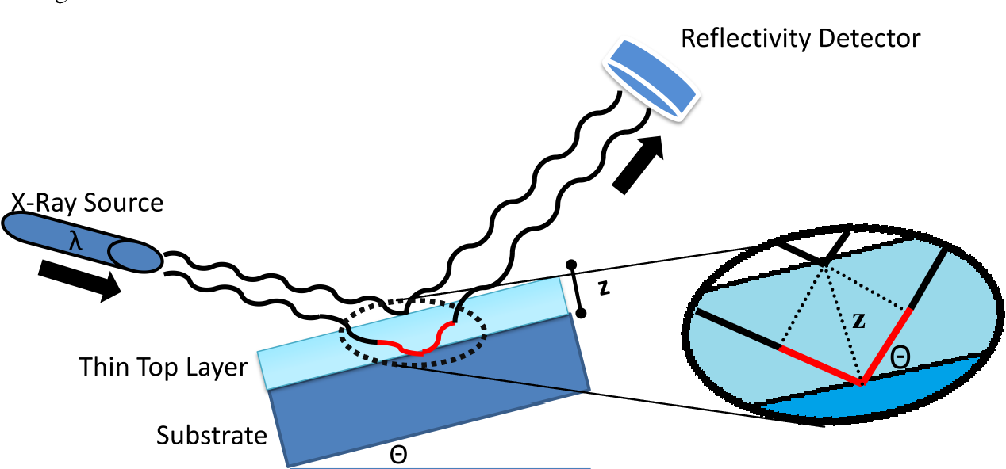

* To perform XRR on copper films of nanometer thickness on Kapton substrate(Sample Size 30mm)
* Since Kapton(density 1.42g/cm3). is not available in the database,it can be added (refer [3.2](#_Region3(Parameters_used_to))
* With an experimental setup,we can operate the instruments with a least count of 0.001 degree,so let us select this value as our step and resolution.
* Let us operate with the incident angle ranging from 2 degree to 4 degree(therefore qz will range from 0.36546667484to 0.73048808485).
* The energy of the beam will be 10KeV. Since we are using a collimator of size 2cm,beam size is 4000um.
* 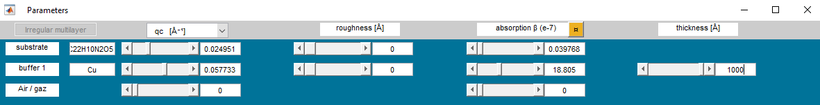For a copper film of thickness 100nm,the plot obtained is shown below

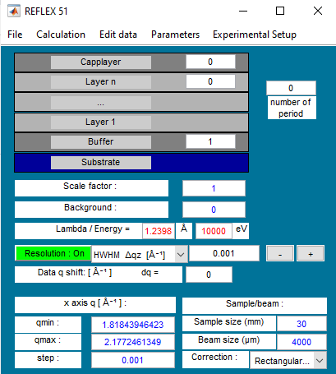

* Now let us find the thickness of the sample from the plot obtained,to verify that the experiment , if we work with these parameters would provide accurate results.

For this we need to-

* Save the file
* Load the saved datafile
* Go to Calculation menubar and select FFT

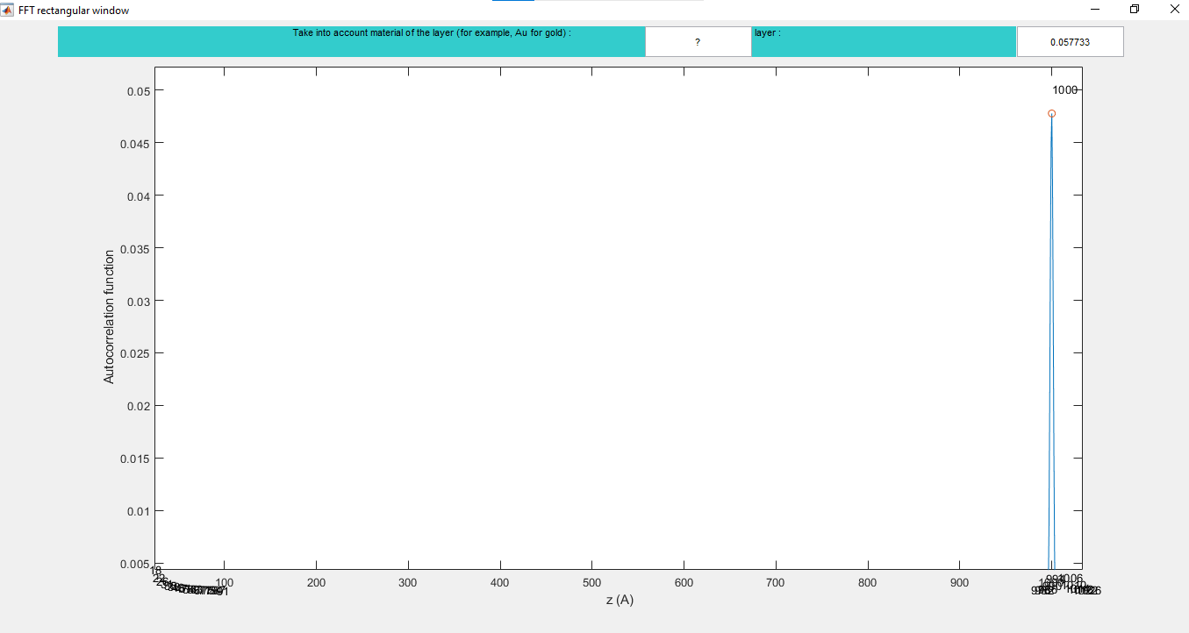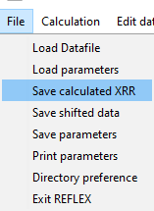

* In the plot above , we can can see that there is a peak at z=1000A(100nm),which corresponds to the thickness of the sample.

# Limitations

* The software is unable to compute the fourier transform for larger angles(or qz)
* Peaks are not obtained for lager steps or resolution .
* For 0.1 step size-

